SQL ASSIGNMENT 4
Q1.Write a select command that produces the order number,amount,and date for all rows in the orders table.
Ans.
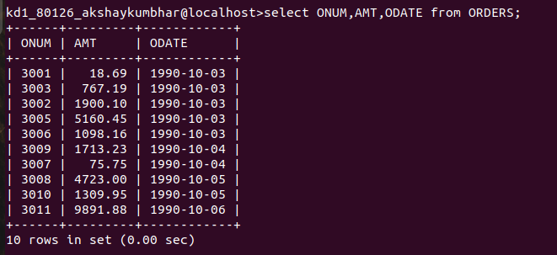

Q2.Write a query that produces all rows from the Customers table for which the Salesperson’s number is 1001.
Ans.

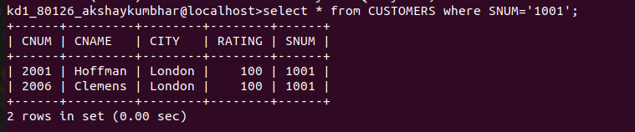

Q3. Write a query that displays the Salespeople table with the columns in the following order:
city,sname,snum,comm.
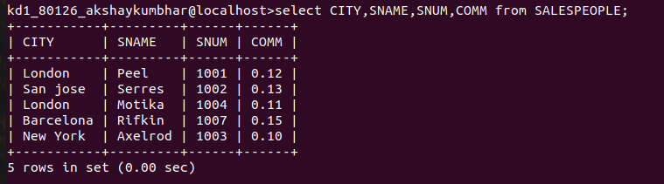
Ans.

Q4.Write a select command that produces the rating followed by the name of each customer in San Jose.
Ans.

